Linux Basic Commands Assignment
You can submit this in a Microsoft Word document or Google Docs along with screenshots and your GitHub repository link.
1. Creating and Renaming Files/Directories
Create a directory named
test_dir
mkdir test_dir
Explanation:
- mkdir is used to create a new directory.
- Here it creates a folder named test_dir.
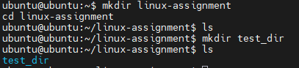
Create an empty file called example.txt inside test_dir
touch test_dir/example.txt
Explanation:
- touch creates an empty file.
- test_dir/example.txt specifies the file location.
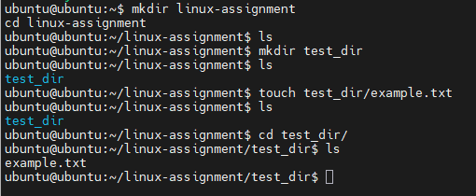

Rename example.txt to renamed_example.txt
mv test_dir/example.txt test_dir/renamed_example.txt
Explanation:
- mv is used to move or rename files.
- Here it renames the file.
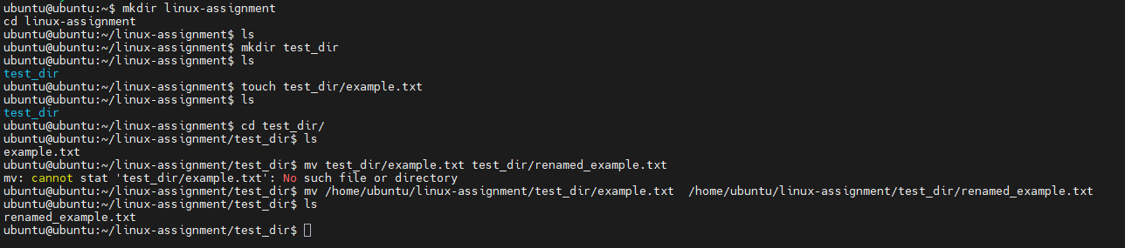
2. Viewing File Contents
Display the contents of /etc/passwd
cat /etc/passwd
Explanation:
- cat displays the entire content of a file.
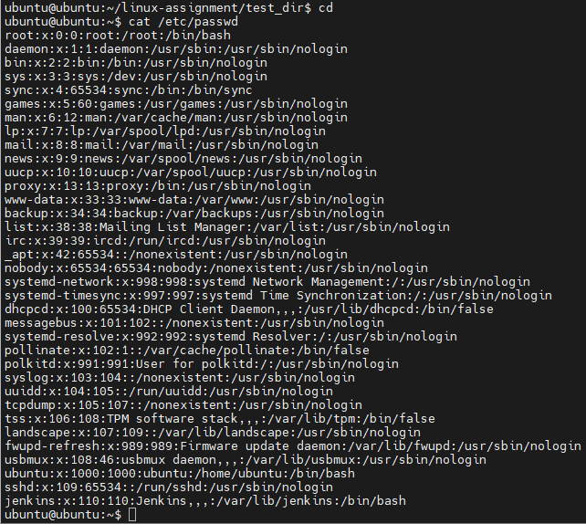
Display only the first 5 lines of /etc/passwd
head -5 /etc/passwd
Explanation:
- head shows the beginning of a file.
- -5 means first 5 lines.
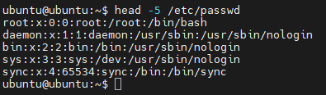
Display only the last 5 lines of /etc/passwd
tail -5 /etc/passwd
Explanation:
- tail shows the end of a file.
- -5 means last 5 lines.
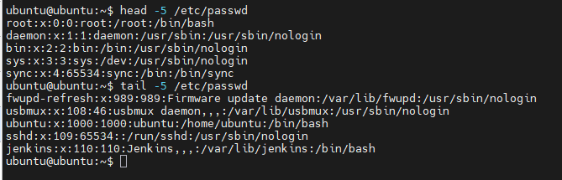
3. Searching for Patterns
Find all lines containing the word root in /etc/passwd
grep "root" /etc/passwd
Explanation:
- grep searches for patterns in files.
- It displays lines containing "root".
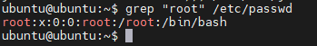
4. Zipping and Unzipping
Compress the test_dir directory into test_dir.zip
zip -r test_dir.zip test_dir
Explanation:
- zip compresses files/directories.
- -r means recursive (include all files inside directories).
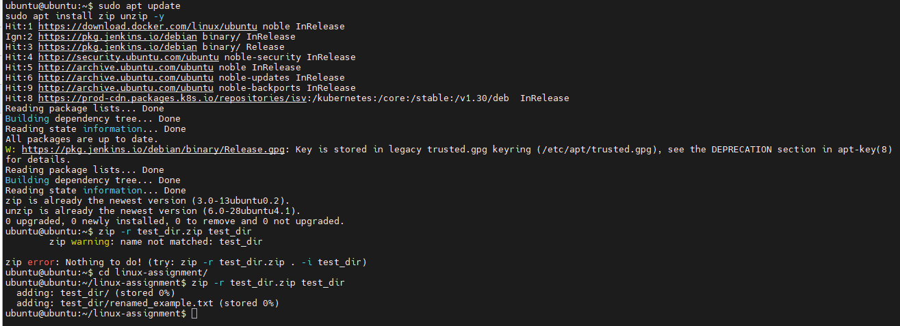
Unzip test_dir.zip into a directory named unzipped_dir
unzip test_dir.zip -d unzipped_dir
Explanation:
- unzip extracts zip files.
- -d specifies the destination directory.
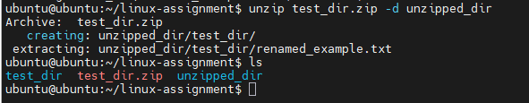
5. Downloading Files
Download a file using wget
wget https://www.google.com/robots.txt
Explanation:
- wget downloads files from the internet using a URL.
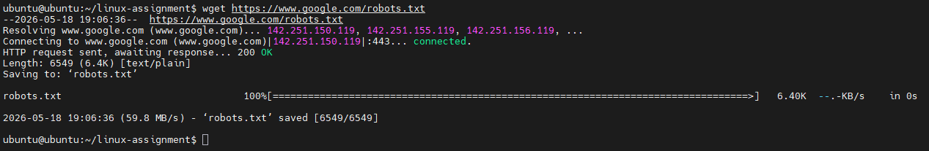

6. Changing Permissions
Create a file named secure.txt
touch secure.txt
Change permissions to read-only for everyone
chmod 444 secure.txt
Explanation:
- chmod changes file permissions.
- 444 means:
  - Owner: Read only
  - Group: Read only
  - Others: Read only
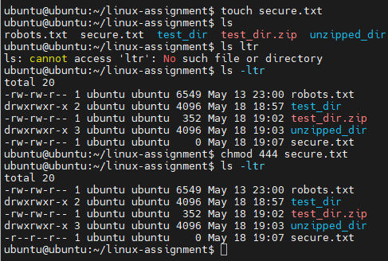

7. Working with Environment Variables
Create a new environment variable

export MY_VAR="Hello, Linux!"

Verify the variable
echo $MY_VAR
Explanation:
- export creates an environment variable.
- echo displays its value.
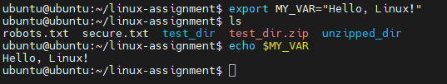
GitHub Submission Steps
Initialize Git Repository
git init
Add Files
git add .
Commit Changes

git commit -m "Linux basic commands assignment"
Add Remote Repository

git remote add origin https://github.com/Mustak22/linux-basic-commands-assignment.git
Push to GitHub

git push -u origin main

